Fundamentals of Software Engineering Coursework 2

UML Modelling and Software Architecture

Project: Campus FoodShare – University Surplus Food Donation & Redistribution Platform

1. Introduction
This document delivers all required deliverables for Coursework 2, building directly on the requirements specification defined in CW1 for the Campus FoodShare platform. It includes UML use case and class diagrams aligned with the functional requirements, a full software architecture design and evaluation, unit test cases for all domain classes, and a complete version control repository plan. No application code is produced, in line with the assignment brief.

2. UML Diagrams
All diagrams are fully traceable to the CW1 requirements specification. No infrastructure-only classes are modelled; all entities represent meaningful domain concepts.

2.1 Use Case Diagram
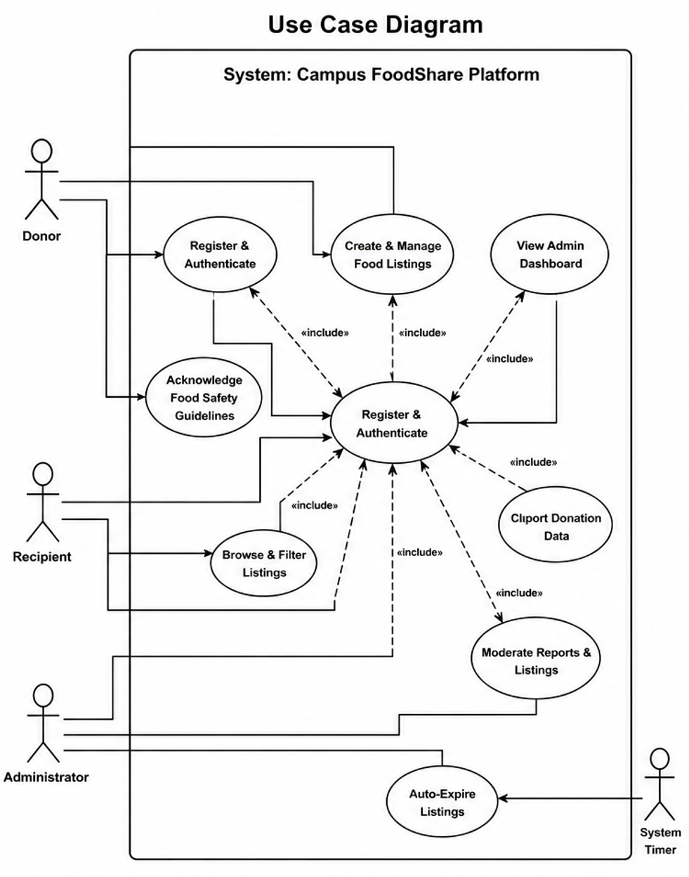
2.2 Class Diagram
